01.students.json
[
{
"studentId":"S001",
"name":"Kalhara",
"email":"mail1@mail.com",
"registered":true,
"courses":[
{
"courseCode":"C001",
"courseName":"C++",
"credits":2

},
{
"courseCode":"C03",
"courseName":"C#",
"credits":3

},
{
"courseCode":"C025",
"courseName":"OOP",
"credits":5

},
{
"courseCode":"C015",
"courseName":"React",
"credits":5

}
]
},
{
"studentId":"S002",
"name":"Saman",
"email":"mail2@mail.com",
"registered":true,
"courses":[
{
"courseCode":"C001",
"courseName":"C++",
"credits":2

},
{
"courseCode":"C025",
"courseName":"OOP",
"credits":5

},
{
"courseCode":"C015",
"courseName":"React",
"credits":5

},
{
"courseCode":"C015",
"courseName":"React",
"credits":5

}
]
},
{
"studentId":"S003",
"name":"Ishara",
"email":"mail3@mail.com",
"registered":false,
"courses":[
{
"courseCode":"C025",
"courseName":"OOP",
"credits":5

},
{
"courseCode":"C025",
"courseName":"OOP",
"credits":5

}
]

},
{
"studentId":"S004",
"name":"Saranga",
"email":"mail4@mail.com",
"registered":true,
"courses":{
"courseCode":"C023",
"courseName":"SOWA",
"credits":3

}
},
{
"studentId":"S005",
"name":"Dulara",
"email":"mail5@mail.com",
"registered":true,
"courses":[
{
"courseCode":"C022",
"courseName":"Java",
"credits":4

},
{
"courseCode":"C023",
"courseName":"SOWA",
"credits":3

},
{
"courseCode":"C015",
"courseName":"React",
"credits":5

}

]
}

]

Index.html
<!DOCTYPE html>
<html lang="en">
<head>
<meta charset="UTF-8">
<title>Student Data</title>
<style>
table {
border-collapse: collapse;
width: 80%;
margin-bottom: 30px;
}
th, td {
border: 1px solid #333;
padding: 8px;
}
th {
background-color: #f2f2f2;
}
ul {
padding-left: 18px;
margin: 0;
}
</style>
</head>
<body>

<h2>All Student Details</h2>
<table id="dataTable">
<thead>
<tr>
<th>Student Id</th>
<th>Name</th>
<th>Email</th>
<th>Registered</th>
<th>Courses</th>
</tr>
</thead>
<tbody></tbody>
</table>

<h2>Registered Student Details</h2>
<table id="dataTable2">
<thead>
<tr>
<th>Student Id</th>
<th>Name</th>
<th>Email</th>
<th>Registered</th>
<th>Courses</th>
</tr>
</thead>
<tbody></tbody>
</table>

<h2>More Than 3 Courses Students</h2>
<table id="dataTable3">
<thead>
<tr>
<th>Student Id</th>
<th>Name</th>
<th>Email</th>
<th>Registered</th>
<th>Courses</th>
</tr>
</thead>
<tbody></tbody>
</table>

<script>
var xhr = new XMLHttpRequest();
xhr.open("GET", "students.json", true);

xhr.onload = function () {
if (xhr.status === 200) {
var data = JSON.parse(xhr.responseText);

var allTable = document.querySelector("#dataTable tbody");
var registeredTable = document.querySelector("#dataTable2 tbody");
var moreThan3Table = document.querySelector("#dataTable3 tbody");

data.forEach(function (student) {

var courses = Array.isArray(student.courses)
? student.courses
: [student.courses];

var courseList = "<ul>";
courses.forEach(function (course) {
courseList += "<li>" + course.courseName + "</li>";
});
courseList += "</ul>";

function createRow() {
var row = document.createElement("tr");
row.innerHTML =
"<td>" + student.studentId + "</td>" +
"<td>" + student.name + "</td>" +
"<td>" + student.email + "</td>" +
"<td>" + student.registered + "</td>" +
"<td>" + courseList + "</td>";
return row;
}

allTable.appendChild(createRow());

if (student.registered === true) {
registeredTable.appendChild(createRow());
}

if (courses.length > 3) {
moreThan3Table.appendChild(createRow());
}
});
}
};

xhr.send();
</script>

</body>
</html>

Output
01.
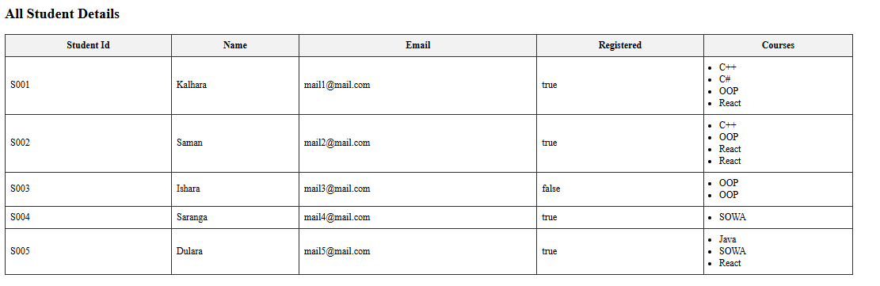

02.
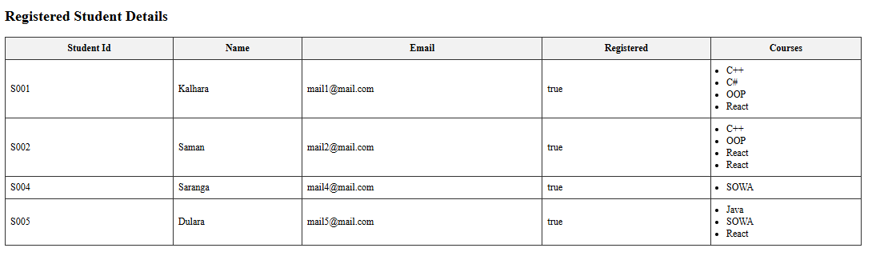
03.
